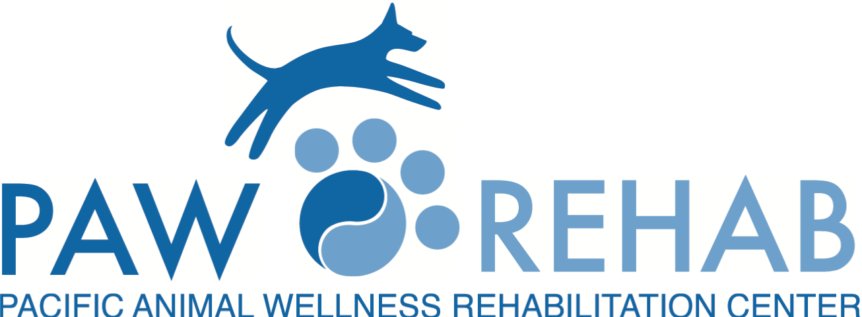
(EMAIL TO INFO@PAWREHAB.COM or via fax 818-860-7672)
VETERINARY REFERRAL FORM Date: _________

DVM INFORMATION:
Referring Doctor: |  |  |  | Preferred Contact Method:
Hospital Name:
Phone: |  | Fax: |  |  | Email:
Address:
City/State: |  |  | Zip Code:
OWNER’S INFORMATION:
Owner’s Name: |  |  | Phone:
Address:
PATIENT’S INFORMATION:
Pet’s Name: |  |  | Date of Birth/Age:
Breed: | Sex: |  |  | Weight:
Presenting Problem:
History:
Diagnostic tests performed (Please include date and results, or if pending, your lab and hospital numbers):
Treatments/Medication (please include dates if possible):
Response to therapy:
Patient being referred for the following services:
☐ Physical Rehabilitation Therapy Consult & Treatment
☐ Integrative Medicine/Acupuncture/Holistic Consultation (may include: Acupuncture, Herbals, Homeopathy, Supplements, Food/Diet Therapy)
☐ Weight Loss & Conditioning Program (Exercise, Diet & Supplements)
☐ Senior Rehabilitation & Wellness Program (Exercise for the Mind & Body, Arthritis Management & Supplements or Herbals for Well-Being)
Additional comments:
Please send radiographs, laboratory tests and a summary of the medical record either by email to info@pawrehab.com or with the
client. Clients may call us to schedule an appointment at 818-847-7299.

